Risk Profiler

Data By:

Area Scenario Training Download About Contact

Without Retrofit

With Retrofit

View By Map View by Rank



Footer

Select Boundary:

Select indicator:

New? Take The Tour

Fatalities

Municipal

Select an area to view data

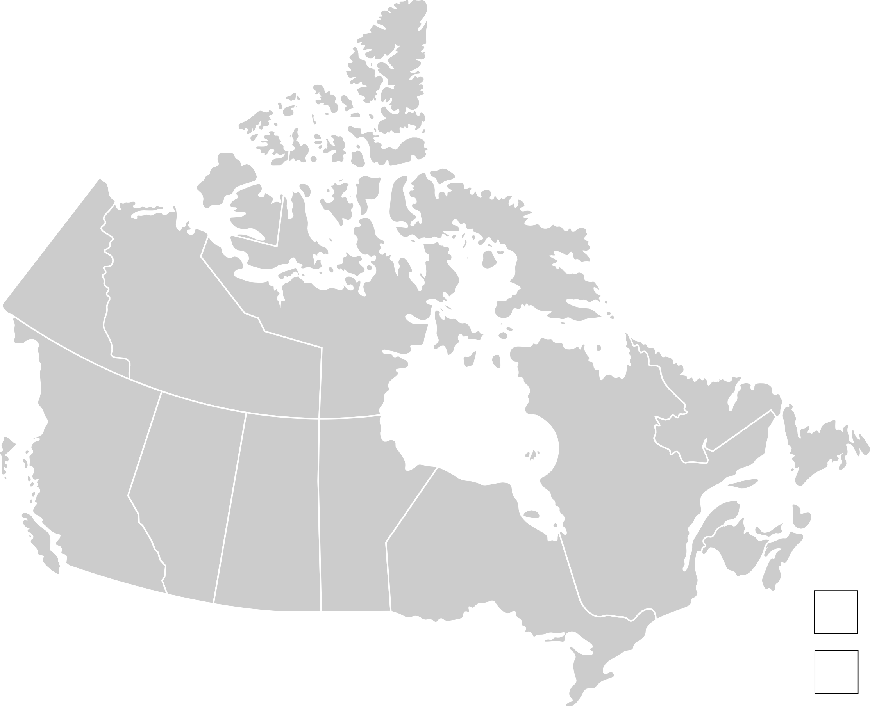

Search

**+**

**-**